NOTICE

All the Students (B.Tech. Electrical Engg.) of Rajkiya Engineering college Ambedkar Nagar are here by informed that they have to complete their practicals in all respect latest up to 30/11/2015 with record files. So they are instructed to present in their respective class rooms as well as in labs on the scheduled timing. Otherwise he will be responsible for all Disciplinary action taken against them.

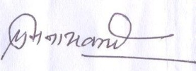
HOD EE

