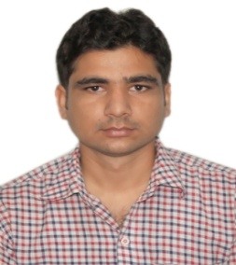**DR. SHIVENDRA KUMAR PANDEY**

*Assistant Professor of Information Technology*

*Rajkiya Engineering College, Ambedkar Nagar*

*(A U. P. State Government Institution)*

*Ambedkar Nagar – 224122 (U. P.) India*

***Mobile:*** +91-8527853396/7007658248

***e-mail:*** *shivaiert@gmail.com/shivendra@recabn.ac.in*

**PROFILE SUMMARY**

***Full Name*** Shivendra Kumar Pandey

***Father’s Name*** Shri Vijay Kumar Pandey

***Date of Joining*** *08/12/2017*

***Department*** *Information Technology*

***Qualification*** **B. Tech** (Computer Science & Engineering)-2012

*Institute of Engineering and Rural Technology, Allahabad (U. P.)*

**M. Tech.** (Computer Science & Applications)-2015

*Jawaharlal Nehru University, New Delhi (New Delhi)*

**Ph. D.** (Multiobjective Clustering in WSN)-2024

*Jawaharlal Nehru University, New Delhi (New Delhi)*

***Additional Roles / Responsibilities at Institute / Department Level (Charge at present):***

* I/C Operation and Maintenance of Internet.
* I/C Website Hosting & Maintenance.
* Co-coordinator Unnat Bharat Abhiyan (UBA).
* Member of Departmental Purchase committee.
* Class Coordinator (IT 3rd Year).
* Member of Anti Ragging Squad.
* I/C. Computer lab 2.
* I/C. IoT and WSN Lab, ITD.
* Member of cell for students from J&K for higher studies.
* Member of anti ragging squad.
* Co-coordinator Virtual Lab IIT Kanpur.
* Member of Media Cell REC Ambedkar Nagar.

***Member of Professional Bodies:***

***Publications:***

***Journal Papers***5 *(Published);* 0*(Accepted);* 2*(Communicated)*

***Conference Papers*** *10 (Published);* 0*(Accepted);* 0 *(Communicated)*

***Workshop/Seminar/Conference/Short Term Courses/Faculty Development Programmes***

***(not less than one week duration):***

40 *(Attended);* 18*(Organized)*

***Key Note Address/Expert Lecture Delivered: 03***

***B. Tech. Projects Supervised***24*(Completed);* 4 *(In Progress)*

***M. Tech. Theses Supervised***0*(Completed);* 0 *(In Progress)*